The Vision

Introduction

The <insert name here> Project Aims to create a web application that will allow users to search through historical documents. Users will be able to view and download the images of the original unesco world heritage documents which date between 1398 and 1509. The project will give the public an unprecedented look glimpse into the detailed history of Aberdeen and the surrounding areas. The project will also allow researchers all over the world to gain access to previously unavailable documents.

The LACR team based within Aberdeen University are currently working to transcribe the original burgh records; The records are currently being transcribed into to xml files to give create a digital and everlasting version of the -often- tattered and worn original documents.

the problem

Although a great deal of work has already gone into transcribing the documents the team currently has no solution to how they are going to make the documents available to the larger public and are not currently accessible to anyone not involved with the project. The project to transcribe the documents has already received funding of £310,000 and Aberdeen council are excited for the project to move forward. Aberdeen’s head archivist Phil Astley said of the project:
"This is a tremendous opportunity for exciting new work with Aberdeen's important collections. It will enable new forms of access to these records, and open up new scope for local, national and international collaborations. We are pleased to be involved in this project which has such long-term potential to enhance Aberdeen's wider cultural offering"

The Solution

Our application aims to make the burgh records as visible and easily accessible as possible. The application will be web based with plans to be supported for multiple browsers, this addresses the need for the application to be accessible. The application is designed primarily to be easy to use -to enhance its appeal to the wider public- but will have powerful advanced search features that will give more advanced users greater specificity when performing searches.

Features

Powerful search
Our search has the capabilities will make finding exactly what you're looking for easy; Autocomplete, search suggestions and multiple advanced search fields all at lightning fast speeds.

Highly Contextual
Relevant Contents of the documents will be displayed around the search term in order to give much greater context. Dates and document ID’s will also be displayed to further enhance this.

Customized Search
A plethora of advanced search fields such as setting a start and end date, document by ID and the ability to search for proper names, aim to make search as concise as possible.

View Images of the Original Documents
All of the original documents are available to view in stunning high resolution images that will allow for true appreciation of the source material.

Read the entire Corpus
The transcribed text of the entire corpus of aberdeen burgh records will be made available giving access to these fascinating and world renowned documents

Business Case

The Competition

There are a number of web applications that aim to allow the user to search through historical documents. However none of the applications are as fully featured as ours and none work as fast as we expect our application to. Some of the competition includes:

1. https://patriotpost.us/documents
2. https://www.usa.gov/history
3. http://www.law.ou.edu/hist/
4. http://www.archives.gov/historical-docs/
5. http://www.british-history.ac.uk/
6. http://www.britannia.com/history/docs/
7. http://salem.lib.virginia.edu/speccol/cmather/table/index.html
8. http://www.hist.cam.ac.uk/seeley-library/online-resources/e-resources/part-i-paper-18
9. http://hum.port.ac.uk/heirs/links.html
10. http://www.historystudycentre.co.uk/infoCenter/infoCenter.do?page=sourcebook
Expenses

Our main expenses during the project will remain relatively low, our main expense during the project will be labour, The cost per hour f for each member of the team will be around £16, or a £30,000 salary if we were to work full time. The project will last a duration of 20 weeks and each member of the team will work 10 hours a week. This means a total of 1000 hours will be given to the project. This means the cost of labour for the project will be £16,000. Another cost will be the price of office space, We believe the cost of one desk annually will be £5000. The project will last 20 weeks so the cost for office space will be £10,500. Another small cost for the project will be hardware depreciation but we estimate this to only be £340.

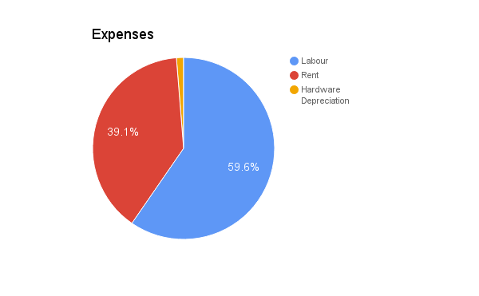

Therefore we believe the total cost for the main elements of project will be £26,840

There will be a number of additional expenses incurred during the duration of the project, these include: Legal advice which we estimate to be around £5000. Travelling costs which we estimate to be around £6000. Bookkeeping which we estimate to cost around £300. We will also need to take into consideration salary costs for additional tasks such as production of demonstrative materials which we believe will take two people 10 hours to create and will therefore cost £320. We will also need to meet with potential customer which will take 2 people 2 hours, this means a cost per meeting will be £64.

This means the total cost of additional expenses is £11,684

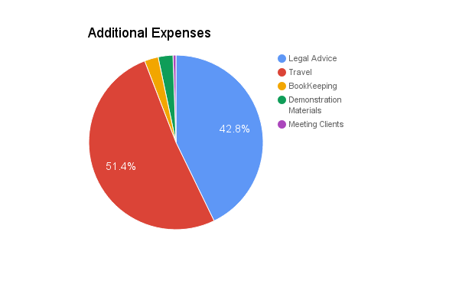

Return on Investment

We plan to sell our application for £10,000 and expect to sell between 25 and 50 copies per year this would generate a yearly net income of between £250,000 and £500,00 the addition of our main expenses and additional expenses comes to a total of £38,524
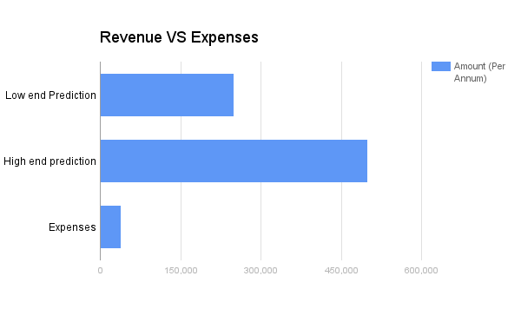
The predicted return on investment for the low end of prediction is 6.48 and for the high end is 12.97 therefore we believe the return on investment even at the low end makes the project well worth while to pursue.

Commercialization

We believe there will be a large market for our application. Many projects similar to the Aberdeen burgh records project are being carried out and we believe our application could be used as way for the output of these project to be delivered to the wider public. Our application could be very easily adapted to accommodate these projects. For this reason we believe we will have a worldwide market.

